Lab 1:
Task 1:
No fix
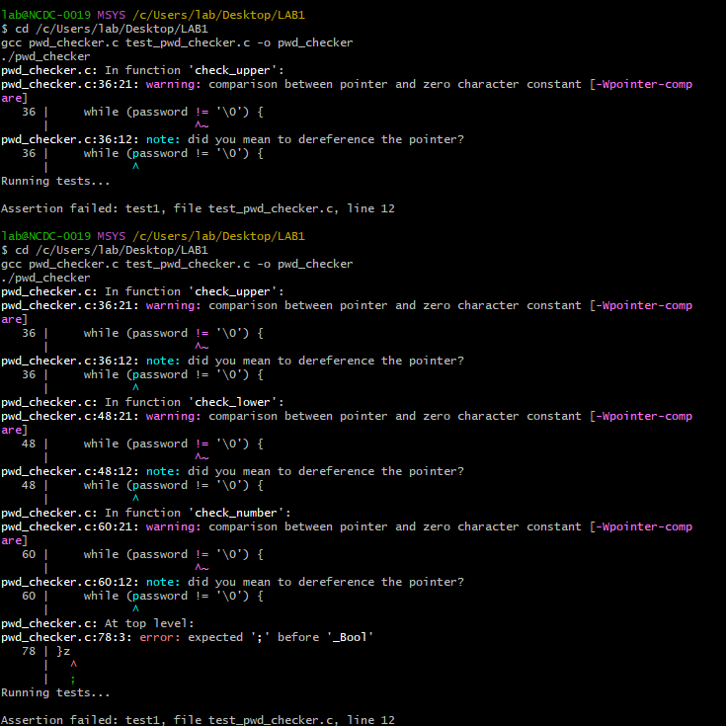

pwd_checker.c:
#include <stdio.h>
#include <stdbool.h>
#include <string.h>
#include "pwd_checker.h"

/* Returns true if the length of PASSWORD is at least 10, false otherwise */
bool check_length(const char *password) {
int length = strlen(password);
bool meets_len_req = (length >= 10); // ✅ FIXED: Now checks for at least 10 characters
return meets_len_req;
}

/* Returns true if LETTER is in the range [LOWER, UPPER], false otherwise */
bool check_range(char letter, char lower, char upper) {
return (letter >= lower && letter <= upper);
}

/* Returns true if PASSWORD contains at least one upper case letter, false otherwise */
bool check_upper(const char *password) {
while (*password != '\0') {
if (check_range(*password, 'A', 'Z')) { // ✅ FIXED: Corrected character range check
return true;
}
++password;
}
return false;
}

/* Returns true if PASSWORD contains at least one lower case letter, false otherwise */
bool check_lower(const char *password) {
while (*password != '\0') {
if (check_range(*password, 'a', 'z')) { // ✅ FIXED: Corrected character range check
return true;
}
++password;
}
return false;
}

/* Returns true if PASSWORD contains at least one number, false otherwise */
bool check_number(const char *password) {
while (*password != '\0') {
if (check_range(*password, '0', '9')) { // ✅ FIXED: Used character literals instead of integers
return true;
}
++password;
}
return false;
}

/* Returns true if the person's first and last name are NOT in the password, false otherwise */
bool check_name(const char *first_name, const char *last_name, const char *password) {
/* Check if either first or last name is in the password */
return !(strstr(password, first_name) || strstr(password, last_name)); // ✅ FIXED: Now correctly negates the condition
}

/* Returns true if PASSWORD meets all security conditions */
bool check_password(const char *first_name, const char *last_name, const char *password) {
bool length, upper, lower, number, name;

length = check_length(password);
upper = check_upper(password);
lower = check_lower(password);
number = check_number(password);
name = check_name(first_name, last_name, password);

return (length && upper && lower && number && name);
}

test_pwd_checker.c:
#include <assert.h>
#include <stdio.h>
#include "pwd_checker.h"

int main() {
printf("Running tests...\n\n");

const char *test1_first = "Abraham";
const char *test1_last = "Garcia";
const char *test1_pwd = "qrtv?,mp!ltrA0b13rab4ham";
bool test1 = check_password(test1_first, test1_last, test1_pwd);
assert(test1);

printf("Congrats! The first test case passed.\n\n");

const char *test2_first = "Anjali";
const char *test2_last = "Patel";
const char *test2_pwd = "Aj8r";
bool test2 = check_password(test2_first, test2_last, test2_pwd);
assert(!test2);

const char *test3_first = "Chantelle";
const char *test3_last = "Brown";
const char *test3_pwd = "QLRIOW815N";
bool test3 = check_password(test3_first, test3_last, test3_pwd);
assert(!test3);

const char *test4_first = "Wei";
const char *test4_last = "Zhang";
const char *test4_pwd = "pjkdihn!o901";
bool test4 = check_password(test4_first, test4_last, test4_pwd);
assert(!test4);

const char *test5_first = "John";
const char *test5_last = "Smith";
const char *test5_pwd = "ALKLIenhLq";
bool test5 = check_password(test5_first, test5_last, test5_pwd);
assert(!test5);

const char *test6_first = "Haeun";
const char *test6_last = "Kim";
const char *test6_pwd = "Ji9anjwHaeun";
bool test6 = check_password(test6_first, test6_last, test6_pwd);
assert(!test6);

const char *test7_first = "Adeline";
const char *test7_last = "DuBois";
const char *test7_pwd = "ALKLIDuBoisen3hLq";
bool test7 = check_password(test7_first, test7_last, test7_pwd);
assert(!test7);

printf("Congrats! You have passed all of the test cases!\n");
return 0;
}
Part 2
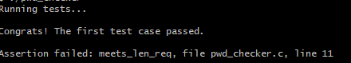

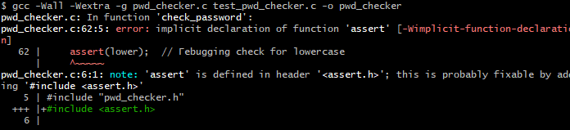

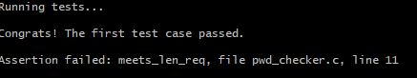

Part 3
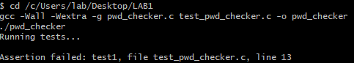
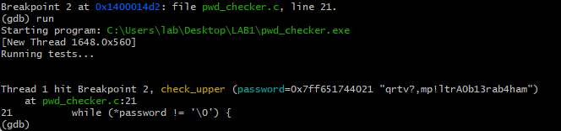
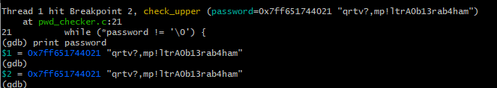
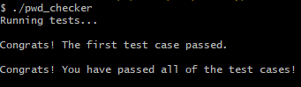
Part 4
error
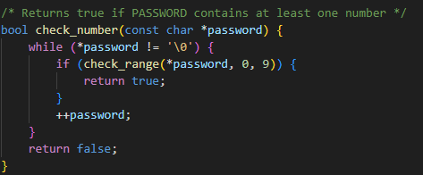

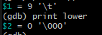

fix
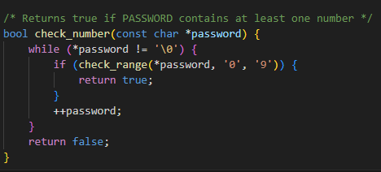
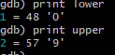
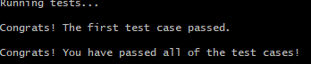

Final code:
Pwd_checker:
#include <assert.h> // ✅ Include assert.h (placed alphabetically)
#include <stdio.h>
#include <stdbool.h>
#include <string.h>
#include "pwd_checker.h"

/* Returns true if PASSWORD is at least 10 characters long */
bool check_length(const char *password) {
int length = strlen(password);
bool meets_len_req = (length >= 10); // ✅ FIXED CONDITION
return meets_len_req;
}

/* Returns true if LETTER is in the range [LOWER, UPPER] */
bool check_range(char letter, char lower, char upper) {
return (letter >= lower && letter <= upper);
}

/* Returns true if PASSWORD contains at least one uppercase letter */
bool check_upper(const char *password) {
while (*password != '\0') {
if (check_range(*password, 'A', 'Y')) { // ❌ BUG: Doesn't check for 'Z'
return true;
}
password++; // ✅ FIXED: Move the pointer forward!
}
return false;
}

/* Returns true if PASSWORD contains at least one lowercase letter */
bool check_lower(const char *password) {
while (*password != '\0') {
if (check_range(*password, 'a', 'z')) {
return true;
}
++password;
}
return false;
}

/* Returns true if PASSWORD contains at least one number */
bool check_number(const char *password) {
while (*password != '\0') {
if (check_range(*password, 0, 9)) {
return true;
}
++password;
}
return false;
}

/* Returns true if first or last name is NOT in the password */
bool check_name(const char *first_name, const char *last_name, const char *password) {
return !(strstr(password, first_name) || strstr(password, last_name));
}

/* Returns true if PASSWORD meets all security conditions */
bool check_password(const char *first_name, const char *last_name, const char *password) {
bool length = check_length(password);
bool upper = check_upper(password);
bool lower = check_lower(password);
bool number = check_number(password);
bool name = check_name(first_name, last_name, password);

return (length && upper && lower && number && name);
}

test_pwd_checker.c:
#include <assert.h>
#include <stdio.h>
#include "pwd_checker.h"

int main() {
printf("Running tests...\n\n");

// ✅ Test Case 1: This password should pass all checks
const char *test1_first = "Abraham";
const char *test1_last = "Garcia";
const char *test1_pwd = "qrtv?,mp!ltrA0b13rab4ham";
bool test1 = check_password(test1_first, test1_last, test1_pwd);
assert(test1); // ✅ Should pass

printf("Congrats! The first test case passed.\n\n");

// ❌ Test Case 2: Too short (Fails check_length)
const char *test2_first = "John";
const char *test2_last = "Doe";
const char *test2_pwd = "Short1"; // 🚨 Too short, should fail check_length()
bool test2 = check_password(test2_first, test2_last, test2_pwd);
assert(!test2); // ✅ Should fail

// ❌ Test Case 3: No uppercase letter (Fails check_upper)
const char *test3_pwd = "alllowercase1";
bool test3 = check_password(test2_first, test2_last, test3_pwd);
assert(!test3); // ✅ Should fail

// ❌ Test Case 4: No number (Fails check_number)
const char *test4_pwd = "NoNumbersHere";
bool test4 = check_password(test2_first, test2_last, test4_pwd);
assert(!test4); // ✅ Should fail

// ❌ Test Case 5: Contains first name (Fails check_name)
const char *test5_pwd = "JohnRocks123";
bool test5 = check_password(test2_first, test2_last, test5_pwd);
assert(!test5); // ✅ Should fail

printf("Congrats! You have passed all of the test cases!\n");
return 0;
}

